Results of the GLM Procedure One Way ANOVA on time until purge of mice torsos

The GLM Procedure

|  |  |  |
| --- | --- | --- |
| **Class Level Information** | | |
| **Class** | **Levels** | **Values** |
| **Dummy** | 9 | 1 2 3 4 5 6 7 8 9 |

|  |  |
| --- | --- |
| **Number of Observations Read** | 270 |
| **Number of Observations Used** | 270 |

The GLM Procedure

Dependent Variable: Time until purge of torsos

|  |  |  |  |  |  |
| --- | --- | --- | --- | --- | --- |
| **Source** | **DF** | **Sum of Squares** | **Mean Square** | **F Value** | **Pr > F** |
| **Model** | 8 | 5623.4667 | 702.9333 | 1.26 | 0.2648 |
| **Error** | 261 | 145598.4000 | 557.8483 |  |  |
| **Corrected Total** | 269 | 151221.8667 |  |  |  |

|  |  |  |  |
| --- | --- | --- | --- |
| **R-Square** | **Coeff Var** | **Root MSE** | **Time_until_purge Mean** |
| 0.037187 | 22.77854 | 23.61881 | 103.6889 |

|  |  |  |  |  |  |
| --- | --- | --- | --- | --- | --- |
| **Source** | **DF** | **Type I SS** | **Mean Square** | **F Value** | **Pr > F** |
| **Dummy** | 8 | 5623.466667 | 702.933333 | 1.26 | 0.2648 |

|  |  |  |  |  |  |
| --- | --- | --- | --- | --- | --- |
| **Source** | **DF** | **Type III SS** | **Mean Square** | **F Value** | **Pr > F** |
| **Dummy** | 8 | 5623.466667 | 702.933333 | 1.26 | 0.2648 |

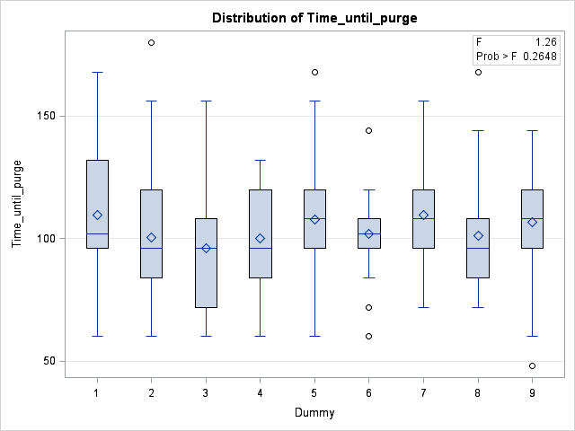

The GLM Procedure

Ryan-Einot-Gabriel-Welsch Multiple Range Test for Time_until_purge

**Note:** This test controls the Type I experimentwise error rate.

|  |  |
| --- | --- |
| **Alpha** | 0.05 |
| **Error Degrees of Freedom** | 261 |
| **Error Mean Square** | 557.8483 |

|  |  |  |  |  |  |  |  |  |
| --- | --- | --- | --- | --- | --- | --- | --- | --- |
| **Number of Means** | **2** | **3** | **4** | **5** | **6** | **7** | **8** | **9** |
| **Critical Range** | 15.552795 | 16.833691 | 17.535001 | 18.009597 | 18.364858 | 18.646704 | 18.646704 | 19.075589 |

|  |  |  |  |
| --- | --- | --- | --- |
| **Means with the same letter are not significantly different.** | | | |
| **REGWQ Grouping** | **Mean** | **N** | **Dummy** |
| A | 109.600 | 30 | *Ignatzschineria indica* |
| A |  |  |  |
| A | 109.600 | 30 | *Salmonella enterica &* *Ignatzschineria indica* |
| A |  |  |  |
| A | 107.600 | 30 | *Escherichia coli & Ignatzschineria indica* |
| A |  |  |  |
| A | 106.800 | 30 | Positive control |
| A |  |  |  |
| A | 102.000 | 30 | *Bacillus licheniformis & Ignatzschineria indica* |
| A |  |  |  |
| A | 101.200 | 30 | Negative control |
| A |  |  |  |
| A | 100.400 | 30 | *Escherichia coli* |
| A |  |  |  |
| A | 100.000 | 30 | *Salmonella enterica* |
| A |  |  |  |
| A | 96.000 | 30 | *Bacillus licheniformis* |

The GLM Procedure

Tukey's Studentized Range (HSD) Test for Time until purge of torso

**Note:** This test controls the Type I experimentwise error rate, but it generally has a higher Type II error rate than REGWQ.

|  |  |
| --- | --- |
| **Alpha** | 0.05 |
| **Error Degrees of Freedom** | 261 |
| **Error Mean Square** | 557.8483 |
| **Critical Value of Studentized Range** | 4.42365 |
| **Minimum Significant Difference** | 19.076 |

|  |  |  |  |
| --- | --- | --- | --- |
| **Means with the same letter are not significantly different.** | | | |
| **Tukey Grouping** | **Mean** | **N** | **Dummy** |
| A | 109.600 | 30 | *Ignatzschineria indica* |
| A |  |  |  |
| A | 109.600 | 30 | *Salmonella enterica &* *Ignatzschineria indica* |
| A |  |  |  |
| A | 107.600 | 30 | *Escherichia coli & Ignatzschineria indica* |
| A |  |  |  |
| A | 106.800 | 30 | Positive control |
| A |  |  |  |
| A | 102.000 | 30 | *Bacillus licheniformis & Ignatzschineria indica* |
| A |  |  |  |
| A | 101.200 | 30 | Negative control |
| A |  |  |  |
| A | 100.400 | 30 | *Escherichia coli* |
| A |  |  |  |
| A | 100.000 | 30 | *Salmonella enterica* |
| A |  |  |  |
| A | 96.000 | 30 | *Bacillus licheniformis* |